International Black Sea University
School of Computer Science and Architecture
Computer Science
Adaptive AI-Driven Productivity Systems
Based on Behavioral State Modeling

Nino Merabishvili
Bachelor’s Thesis in Computer Science

Supervisor: Anri Morchhiladze

Tbilisi, 2026

TABLE OF CONTENTS

Abstract ……………………………………………………………………………..… p. 4
Acknowledgements ..………………………………………………………………..… p. 4
Introduction ..………………………………………………………………………..… p. 6
Chapter 1: Theoretical Framework and Literature Review4 ………………………..… p. 10
1.1 Defining Productivity in Knowledge Work4 …………………….……………….. p. 10
1.2 Cognitive Load Theory5 …………………….………………………………….… p. 11
1.3 Self-Determination Theory6 ……………….………………………………….……p. 12
1.4 Temporal Motivation Theory and Procrastination7 ……………………..…...…….p. 12
1.5 Sleep and Cognitive Performance8 ……………………..…...………………….….p. 13
1.6 Personal Informatics Systems9 ……………………..…...………………………….p. 14
1.7 Gamification and Behavioural Change10……………………..……………...…….p. 15
1.8 Existing Systems and Research Gap11……………………..…...……………….….p. 15
Chapter 2: System Design and Architecture12……………………..…...……………….p. 10
2.1 Design Philosophy12……………………..…...…………………………………….p. 17
2.2 Architecture Overview13………………………………………………...…...…….p. 17
2.3 Onboarding and User Modelling14………………………………..……..…...…….p. 18
2.4 Energy Intelligence Engine15……………………..…………………………..…….p. 19
2.5 Cognitive Load Routing Algorithm16………………………………..…..…...…….p. 20
2.6 AI Co-Pilot Architecture18……………………..…...…………………………...….p. 21
2.7 Gamification and Behavioural Data Layer19……………………………..…...…….p. 10
Chapter 3: Research Methodology20………………………………………….…...…….p. 10
3.1 Research Design20……………………..…...……………………………………….p. 10
3.2 Participants21……………………..…...…………………………………………….p. 10
3.3 Measurement Instruments21………………………………….…………..…...…….p. 10
3.4 Procedure23……………………..……………………………………………..…….p. 10
3.5 Statistical Analysis Plan23…………………………..…………………..…...…….p. 10
3.6 Ethical Considerations24……………………..……………………………...…….p. 10
Chapter 4: Results and Discussion25………………………………………..…...…….p. 10
4.1 Descriptive Statistics25……………………..…...………………………………...p. 10
4.2 Task Completion Rate26……………………..…...……………………………….p. 10
4.3 Cognitive Load Index27……………………..……………………………...…….p. 10
4.4 Sleep Quality27……………………..…...………………………………………..p. 10
4.5 Procrastination Frequency28…………………………………………..…...….….p. 10
4.6 Subjective Well-Being and Burnout Risk28…………………………..…...….….p. 10
4.7 Discussion29……………………..…...……………………………………….….p. 10
Conclusion31……………………..…...…………………………………………....….p. 10
References33………………………………………………………….……..…...…….p. 10

ABSTRACT

Current productivity software is essentially blind to the user's actual state. It hands you a list and expects uniform output regardless. Cognitive psychology has known this model is broken for decades. This thesis is a direct attempt to fix it.

Freeside is built on Cognitive Load Theory (Sweller, 1988), Self-Determination Theory (Deci & Ryan, 2000), and Temporal Motivation Theory (Steel, 2007) — not as theoretical decoration, but as direct architectural inputs. I designed the system around a single premise: before routing a task to a user, the system should know something real about their current cognitive state. To do that, Freeside feeds a user's Google Calendar data into a large language model, which infers their present energy level and surfaces an estimate for confirmation. From there, I built the CLCS algorithm to translate that inferred state into concrete scheduling decisions — matching task cognitive demand to available capacity, in real time, on every session.

I ran a four-week quasi-experimental study (N=10) tracking cognitive load (NASA-TLX), sleep (PSQI), procrastination (PPS), stress (PSS-10), and objective task completion logs. Four of the five measures moved significantly. Task completion jumped from 54.3% to 71.8% ($p = .031, d = 0.78$). Cognitive load fell sharply from 58.4 to 44.2 ($p = .018, d = 0.91$). Procrastination ($p = .044$) and stress ($p = .027$) also saw significant reductions, while sleep quality improved directionally but inconclusively ($p = .089$).

Embedding behavioural science directly into scheduling logic produces real, measurable change. The next priority is a properly powered RCT to test it at scale.

*adaptive task management · cognitive load · behavioural state modelling · AI-driven productivity · personal informatics · burnout prevention*

INTRODUCTION

1. Background and Motivation

The modern knowledge worker faces a paradox. Task managers, intelligent calendars, project management platforms, AI-powered assistants — these tools have never been more capable. The productivity crisis, though, has not abated. By most measures it has worsened, tracking upward in near-perfect step with the sophistication of the systems built to contain it.

This tension is what drove me to build Freeside. I lived it before I researched it. Cycling through productivity systems for years — each one logically coherent, each one eventually inadequate — clarified one thing: the tools were not failing because engineers built them badly. They failed because they modelled the person using them as a fixed variable. Constant. Predictable. Unaffected by circumstance.

At scale, that assumption carries a cost. In 2019, the World Health Organisation classified burnout as an occupational phenomenon — one affecting an estimated 67% of all workers (WHO, 2019). That figure names the most visible symptom. Beneath it: chronic procrastination affecting roughly 20% of the adult population to a clinically significant degree (Steel, 2007), and sleep deprivation tied to work-related rumination costing OECD economies approximately $680 billion annually in lost productivity (Rand Corporation, 2016). None of this reflects individual failure. These are the predictable outputs of systems designed without a model of human variability.

Contemporary productivity software encodes a specific user: cognitively uniform, consistently available, indifferent to fatigue or stress. No task list carries a representation of the person reading it. Between a user who arrived rested and focused and one running on five hours of sleep after back-to-back meetings — the software draws no distinction. That gap is not a minor design oversight. It is the root cause.

2. Research Problem

Straightforward to state, this problem has proven surprisingly difficult to solve. No widely available personal productivity tool dynamically adapts its task presentation and scheduling logic to a real-time model of the user's psycho-cognitive state, grounded in validated behavioural science. Building Freeside meant confronting that gap directly — and confronting why it persists.
Structurally, established systems like Todoist, Notion, Asana, and ClickUp are sophisticated list managers. What users intend to do, they record. Whether a given user, at a given moment, holds the cognitive capacity to execute — that, they do not model. A high-demand analytical task sits beside a routine administrative item. No differentiation. No signal. No adaptation. Toward the human operating it, the system maintains perfect indifference. That indifference is not a missed opportunity. It is actively harmful.

3. Research Questions

Five primary research questions structure this thesis:
- Through energy-aligned task routing — implemented as a weighted cognitive load compatibility algorithm — does task completion rate improve measurably against participants' unaided baseline?
- Across the study period, does the adaptive interface produce a statistically significant reduction in self-reported cognitive load as measured by the NASA Task Load Index?
- Between Freeside use and self-reported sleep quality, as measured by the Pittsburgh Sleep Quality Index, is there a measurable relationship?
- By deploying the AI Co-Pilot's micro-step generation and proactive intervention system, does procrastination frequency decline as captured by the Pure Procrastination Scale?
- Over sustained use, does Freeside reduce burnout risk indicators as measured by the Perceived Stress Scale (PSS-10)?

4. Scope and Delimitations
Individual, self-directed productivity in knowledge work and academic contexts defines the research focus. Team productivity, organisational workflows, and physical labour fall outside it. Bounding the study: a four-week intervention period, a convenience sample of ten participants. That scale suits proof-of-concept evaluation. It does not support broad causal inference, and this thesis does not claim otherwise. On the technical side, the implementation is web-based. Native mobile development — an obvious next step — is deferred.

5. Contributions
Four substantive contributions emerge from this work.
By drawing on calendar data processed through a large language model, the first contribution introduces a behavioural state modelling system that infers cognitive energy in near-real time. Fully automating that inference was the original target. During implementation, sparse or structurally atypical calendar data produced error rates that made full automation untenable — which pushed the design toward a human-in-the-loop architecture. The system now generates an AI-suggested energy estimate.

The user confirms or corrects it. That interaction pattern represents a novel approach to passive energy sensing in personal informatics.

The second contribution is a formally specified Cognitive Load Compatibility Scoring (CLCS) algorithm. By matching task cognitive demand against current user capacity — and applying a time-of-day weighting for user-reported peak focus windows — the algorithm drives the core routing logic.

From the pilot study, the third contribution is empirical: data supporting the hypothesis that adaptive, energy-informed task routing produces measurable improvements in productivity outcomes.
Rounding out the four: the full system architecture is documented to a standard that enables independent replication and extension.

6. Thesis Structure
Grounding the system design theoretically, Chapter 1 draws on cognitive psychology, motivational theory, personal informatics, and gamification research. In Chapter 2, Freeside's architecture, implementation, and core algorithmic components receive full treatment. Chapter 3 covers the research methodology — study design, measurement instruments, analysis plan. Chapter 4 reports and interprets pilot evaluation results. Closing the thesis: a synthesis of findings, their theoretical and practical implications, identified limitations, and directions for future work.

CHAPTER 1: THEORETICAL FRAMEWORK AND LITERATURE REVIEW

1.1 Defining Productivity in Knowledge Work

Applied to knowledge work, productivity defies simple definition. Industrial origins gave the term a clean meaning: output divided by input. That worked for manufacturing. Output was countable. It was homogeneous (Taylor, 1911). Knowledge work broke that formula.

Extending it proved harder than expected. Drucker (1999) called the challenge "the biggest management challenge of the twenty-first century." Quantity of output, he argued, tells you almost nothing. Goal alignment matters. So does task quality. Sustainable performance has to enter the calculation too — and none of those variables fit neatly into a ratio.

Within the human-computer interaction literature, researchers have operationalised productivity in several ways. Through foundational diary studies of task management behaviour among professionals, Bellotti et al. (2004) found that users completed an average of 59% of their planned daily tasks.

Completion rates rose when tasks were prioritised against available time and energy. That finding matters. Mark et al. (2014) pushed further still — using experience-sampling methods to show that productivity follows predictable within-day rhythms. Peak performance windows vary systematically by individual, time of day, and the type of activity that immediately preceded them. That body of evidence establishes the empirical basis for a central claim of this thesis: adaptive, temporally aware task management systems can outperform static alternatives.

For the purposes of this work, productivity is defined as the proportion of cognitively appropriate, self-identified tasks that a user successfully completes within a given time window. Cognitive load compatibility adjusts that proportion against the user's current capacity. Chapter 3 operationalises this through the Task Completion Rate (TCR) metric.

1.2 Cognitive Load Theory

Introduced by Sweller (1988) and extended by Sweller, van Merriënboer, and Paas (1998), Cognitive Load Theory (CLT) provides the primary theoretical foundation for Freeside's task routing architecture. Human working memory is finite. Cowan (2001) put the ceiling at approximately four chunks of information simultaneously. Exceed that ceiling, and performance degrades. Measurably. Consistently. Sweller calls the excess "extraneous load" — and its effects on learning, decision-making, and output quality are extensively documented.

CLT distinguishes three load types. Intrinsic load is inherent to the task itself, determined by element interactivity. Generated by poor instructional or environmental design, extraneous load is largely avoidable. Germane load is different — it is the cognitive effort directed toward schema construction and automatisation, and it is productive. For this thesis, intrinsic cognitive load is the operative construct. Each task in Freeside carries a user-reported "cognitive load score" — a rating of its inherent mental demand on a scale of one to ten. By comparing that score against the user's current cognitive capacity, the routing algorithm implements CLT's core prescriptive implication directly: match task demand to available cognitive resources.

Measuring cognitive load in applied contexts requires a reliable instrument. Hart and Staveland (1988) developed exactly that. The NASA Task Load Index (NASA-TLX) assesses six dimensions: mental demand, physical demand, temporal demand, performance, effort, and frustration. In Chapter 4, it serves as the primary cognitive load measure across the evaluation study.

1.3 Self-Determination Theory

Developed by Deci and Ryan (1985, 2000), Self-Determination Theory (SDT) proposes that human motivation and psychological well-being depend on satisfying three basic psychological needs. Autonomy is the need to feel that one's actions are self-endorsed and volitional. Competence is the need to feel effective. Relatedness is the need to feel connected to others. Satisfy these needs, and SDT predicts intrinsic motivation, sustained engagement, and psychological well-being. Frustrate them, and motivation collapses. Burnout follows.

Freeside's design implements SDT's prescriptions in three distinct ways. First, task rerouting is framed as a supportive suggestion — never a system override. Users can always override the algorithm's recommendations. That choice reflects Ryan and Deci's (2017) finding that autonomy-supportive contexts consistently produce superior motivation and persistence outcomes.
Controlling contexts produce the opposite. Second, through the AI Co-Pilot's micro-step generation feature, large intimidating tasks get decomposed into small, achievable steps. This directly addresses the "competence threat" that Elliot and Dweck (2005) identified as a primary driver of task avoidance. Third, experience points, progress indicators, and achievement badges provide immediate competence feedback. That feedback loop is consistent with SDT's finding that positive competence feedback enhances intrinsic motivation (Deci et al., 1999).

1.4 Temporal Motivation Theory and Procrastination

Synthesising 216 studies, Steel (2007) produced the most comprehensive quantitative analysis of procrastination to date. His central finding reframes the problem entirely. Procrastination is not a time management failure. It is a self-regulatory failure — rooted in emotion regulation. People avoid tasks because those tasks elicit negative affect: anxiety, boredom, self-doubt. Avoidance provides immediate emotional relief. It does so at the cost of long-term goal pursuit. Steel formalised this in Temporal Motivation Theory (TMT), modelling motivation as a function of four variables: expectancy of success, subjective value of the task, impulsiveness, and delay to reward.

From that base, Sirois and Pychyl (2013) argue that effective anti-procrastination interventions must target the affective antecedents of avoidance. Exhorting more effort is not enough. Freeside's design responds to that prescription through three mechanisms. By eliminating "overdue" notifications entirely — reframing rerouted tasks as "saved for a better energy window" rather than "late" — the system removes the primary guilt-inducing trigger of avoidance. Through micro-step generation, the AI Co-Pilot raises TMT's "expectancy of success" variable. It does this by reducing the perceived magnitude of pending tasks. And by deploying proactive interventions at low-energy states, Freeside provides in-the-moment affective support — consistent with Ferrari et al.'s (1995) finding that emotional regulation support at the point of temptation outperforms pre-task planning alone.

1.5 Sleep and Cognitive Performance

Few relationships in cognitive neuroscience are as robustly established as the one between sleep and cognitive performance. Van Dongen et al. (2003) ran a landmark dose-response study. Participants were restricted to six hours of sleep per night over seventeen consecutive days. The resulting cognitive impairment was equivalent in magnitude to two nights of total sleep deprivation. Critically, participants did not know it. They consistently rated their own sleepiness as manageable. That metacognitive blind spot poses a significant challenge for self-managed productivity systems that rely on user self-report.

Across 56 studies, Pilcher and Huffcutt's (1996) meta-analysis found that sleep deprivation hit mood hardest. Cognitive performance came second. Motor performance came third — and those are precisely the faculties knowledge work depends on most. Tracing a mediational pathway from work-related stressors through cognitive rumination to sleep impairment, Berset et al. (2011) suggest that reducing work-related stress may produce downstream improvements in sleep quality. A specific mechanism connects task management quality to sleep onset: the Zeigarnik effect. Unfinished tasks intrude into consciousness — including during pre-sleep cognitive states (Zeigarnik, 1927; Baumeister & Masicampo, 2011). By explicitly scheduling heavy tasks to future optimal windows, Freeside's rerouting mechanism reduces the pool of psychologically "open" tasks at day's end. That reduction may lower rumination. Whether it improves sleep onset is a hypothesis examined in Chapter 4.

1.6 Personal Informatics Systems

As a research artefact, Freeside operates within the framework Li, Dey, and Forlizzi (2010) established in their stage-based model of personal informatics systems. Five stages define self-tracking behaviour: preparation, collection, integration, reflection, and action. Most personal informatics systems handle collection robustly. At integration and reflection, they consistently fail — producing data silos that accumulate without ever driving behaviour change. Freeside is designed to compress all five stages into a single continuous loop. Energy and behavioural data are collected automatically. In real time, this data integrates with calendar and task data. Through the insights dashboard, it surfaces as reflection — and feeds directly into the routing algorithm as action. No separate manual reflection step. That architecture positions Freeside as a closed-loop personal informatics system: one where collected data immediately produces behaviour-modifying outputs.

By ethnographically studying self-tracking practices, Rooksby et al. (2014) introduced a distinction that directly shaped Freeside's design: "goal-oriented" versus "learning-oriented" tracking. Users who persist with self-tracking tools do so because the data is immediately actionable. Not merely informative. Every data point Freeside collects is therefore designed to produce a visible change in system behaviour within the same session.

1.7 Gamification and Behavioural Change

Deterding et al. (2011) established the foundational definition: gamification is "the use of game design elements in non-game contexts." Reviewing 24 empirical gamification studies, Hamari, Koivisto, and Sarsa (2014) found that the large majority reported positive effects on target behaviours. Points, badges, leaderboards, and progress indicators consistently drove engagement. Context and individual differences moderated those effects — in ways that matter for design decisions.

A complementary lens comes from Fogg's (2009) Behaviour Model. Behaviour change, Fogg proposes, occurs at the intersection of sufficient motivation, adequate ability, and a well-timed trigger. Freeside's gamification layer maps directly onto that model. Experience points and achievement badges address motivation. By reducing task complexity to manageable sub-goals, micro-step generation addresses ability. Proactive AI interventions serve as triggers — deployed at the optimal cognitive moment, immediately after energy confirmation, when the user is already primed to engage.

1.8 Existing Systems and Research Gap

Across leading productivity applications, one structural limitation repeats. Todoist, Asana, ClickUp, Notion, and Monday.com all operate as static task repositories with manual prioritisation. None implement automated cognitive load assessment. Real-time user energy goes unmodelled. Tasks are never routed adaptively. The closest commercial analogues to Freeside's approach are Superhuman, which applies AI to email triage, and Reclaim.ai, which automates calendar scheduling. Neither models cognitive state. Neither connects productivity planning to well-being outcomes. The gap remains open.

In the academic literature, the same gap appears. Investigating cognitive costs of task switching in knowledge work, Iqbal and Bailey (2010) proposed "breakpoints" as optimal moments for interruption — but produced only a passive suggestion engine. Adaptive routing was not part of the design. Through research on ultradian rhythms and their relationship to cognitive performance, Mark et al. (2014) established the empirical foundation for time-sensitive task routing. They never built the system. By translating that body of empirical work into a complete, functional, and evaluated adaptive productivity platform, this thesis addresses that gap directly.

CHAPTER 2: SYSTEM DESIGN AND ARCHITECTURE

2.1 Design Philosophy

From conventional productivity software, Freeside departs on a single principle: the system adapts to the human. Not the other way around. This thesis terms that principle "human-centric adaptivity." Three concrete design commitments operationalise it.

First, real-time cognitive state modelling drives system behaviour — the model updates, and the interface changes with it. Second, guilt and pressure are structurally prohibited. Punitive "overdue" language is replaced entirely with empathetic, forward-looking guidance. Third, every feature traces to a specific, empirically validated finding in behavioural science. If a design decision cannot be anchored to the literature, it does not ship.

Hard implementation constraints follow directly from these commitments. Undifferentiated task lists are not an option. Every surface the user sees is filtered by cognitive load compatibility. Red colour, overdue badges, and urgency-inducing typography are banned outright. Visual feedback must be calming and progress-oriented. Generic Co-Pilot advice is equally prohibited — every response must reference the user's current energy level, active goals, and pending tasks. Either the system knows the user's context, or it says nothing.

2.2 Architecture Overview

Built as a web-based SaaS application, Freeside runs on a three-tier architecture. On the frontend, a React application runs on the Next.js 16.2.7 framework. Serving REST and WebSocket endpoints, the backend is a Python FastAPI service. Underneath both sits a Supabase-hosted PostgreSQL instance augmented with vector storage capabilities. All AI capabilities route through the Gemini API (Gemini 2.5 Flash) via the backend services layer.
None of these choices are defaults. Next.js 16.2.7 with the App Router pattern delivers server-side rendering. That reduces initial load latency — a non-trivial concern for a tool users open at the start of every working day. Over Django or Express, FastAPI was chosen because Python's ecosystem provides native access to the scientific and machine learning libraries that analytics and prediction features will require in later development phases. For three specific reasons, Supabase was chosen over raw PostgreSQL: its integrated authentication system, Row Level Security (RLS) policies that enforce data isolation between users at the database level, and real-time subscription capabilities that drive the live dashboard updates central to the user experience.

Six primary components constitute the complete system. These are the Onboarding and User Modelling System, the Energy Intelligence Engine, the Cognitive Load Routing Algorithm, the AI Co-Pilot, the Gamification and Progress Layer, and the Behavioural Analytics Engine. Each is described in the sections that follow.

2.3 Onboarding and User Modelling

Where Freeside builds its initial user model is onboarding — and that model informs every subsequent AI decision the system makes. Presented once on account creation, the flow is a four-screen wizard. Following the pre-loading approach Colombo et al. (2019) recommend for reducing cold-start limitations in personalised recommendation systems, each screen front-loads data the engine needs before it can behave intelligently.

Screen one collects identity and context: name, occupational role (student, professional, entrepreneur, or other), and a free-text response to the prompt "in your own words, what does a truly productive day look like for you?" That last response gets stored in the user profile. Verbatim, it is injected into the Co-Pilot's system prompt for every subsequent session — anchoring every recommendation the assistant makes to the user's own definition of success.
On screen two, primary goals are collected: a minimum of one and maximum of three objectives, each tagged with a category (work, personal, health, or learning) and a timeframe. Stored in the goals table, these are retrieved via semantic similarity search during Co-Pilot context construction. Screen three captures work style preferences: peak focus time (morning, afternoon, or evening), typical daily working hours, and preferred work cadence (long deep-focus blocks, short sprints with breaks, or flexible). On screen four, the optional Google Calendar OAuth 2.0 connection is initiated. Completing it activates the Energy Intelligence Engine.

2.4 Energy Intelligence Engine

At the core of this thesis sits the Energy Intelligence Engine. The engine replaces self-report with an AI-inferred estimate derived from objective calendar data — which the user then confirms or adjusts. The distinction matters. The system leads with evidence. The user refines it.

Each morning, when the user opens the application, the engine runs three stages. In stage one, using the OAuth 2.0 refresh token stored in the user profile, the calendar fetcher retrieves the user's events for the current day from the Google Calendar API. Four values are extracted: event count, total meeting duration in minutes, the number of back-to-back meeting pairs (consecutive events with fewer than fifteen minutes between end and start times), and an event summary list of titles and durations.

In stage two, this structured calendar summary passes to the Gemini API. A carefully engineered prompt instructs the model to estimate the user's likely cognitive energy level based on meeting density, scheduling pattern, and stated work style preferences. Critically, the model is constrained to respond exclusively in structured JSON. Three fields only: a numeric score from one to ten, a categorical level (high, balanced, or low), and a reasoning statement of no more than twenty words. That constraint is not incidental. Verbose model responses would degrade the user experience and make reliable parsing impractical.

In stage three, the frontend renders the AI suggestion as a pre-filled slider. Alongside it, the model's reasoning appears in plain language — for example: "You have four meetings today, including a two-hour strategy session. Freeside estimates your energy for deep work will be moderate: 5/10." One tap confirms. A slider adjustment overrides. Both the AI-suggested score and the user-confirmed score are written to the energy_logs table. That logging creates a longitudinal dataset of the divergence between AI inference and human self-report. Its analytical value extends well beyond this thesis.

2.5 Cognitive Load Routing Algorithm

As the primary technical contribution of this thesis, the Cognitive Load Compatibility Scoring (CLCS) algorithm takes the user's confirmed energy score and produces a ranked, filtered task list. Every visible task in that list is cognitively compatible with the user's current capacity. Running in the backend services layer as a pure function, the algorithm accepts three inputs: a list of task objects, an energy score, and the user's peak focus time preference.

First, an effective capacity score is computed. When the current time falls within the user's stated peak focus window, the energy score increments by one point, capped at ten. Directly implementing Mark et al.'s (2014) empirical finding, this adjustment accounts for the fact that cognitive performance is systematically higher during individual peak focus periods — independent of momentary self-reported energy.

For each task, a cognitive load delta is computed: the difference between the task's cognitive load score and the user's effective capacity. At a delta of two or less, the task is classified as compatible and placed in the active task list. Above two, it is classified as incompatible and routed to the rerouted task list. Compatible tasks receive a priority score equal to ten minus the absolute value of the delta. Tasks that most precisely match current capacity rank highest. Sorting by priority score descending, the active list surfaces the most energetically optimal task at the top of the user's view.

Rerouted tasks appear in a collapsed accordion at the bottom of the task view, labelled "[N] tasks saved for a better energy window." Each is annotated with a recommended energy level for optimal engagement. That framing implements Sirois and Pychyl's (2013) recommendation directly: eliminate guilt-inducing language and replace it with forward-looking, competence-affirming alternatives. To the session_logs table, every routing event is logged with a was_rerouted flag — generating the dataset for the rerouting frequency analysis in Chapter 4.

2.6 AI Co-Pilot Architecture

Built on the Gemini API, the AI Co-Pilot is a context-aware conversational assistant with a dynamically constructed system prompt. It is not a general-purpose assistant. Static prompts are not used. For every request, the system prompt is regenerated using live data pulled from the user's profile, goals, current energy state, and pending task list. This implements a Retrieval-Augmented Generation (RAG) architecture. The retrieval component is a set of structured database queries rather than a vector similarity search.

Per request, the context builder executes four database queries. First, it retrieves the user profile — work style preferences and the stored productive-day description. Second, active goals are fetched. Third, the most recent energy log entry is pulled, including both AI-suggested and user-confirmed scores. Fourth, the top five pending tasks are retrieved, ordered by priority score. From this structured context, a system prompt is assembled that grounds the model in the user's identity, current state, active goals, and pending work. Three hard behavioural constraints are enforced within it: the model must not suggest deep work to a user in a low-energy state; when asked to break down a task, it must produce exactly three to five micro-steps, each under fifteen words; and all responses must stay under one hundred twenty words unless explicitly generating a task breakdown.

Two modes define Co-Pilot operation. In reactive mode, it responds to explicit user queries through the chat interface. In proactive mode — the more theoretically significant of the two — context-appropriate interventions are generated without user initiation. When a user confirms a low-energy state, the system automatically sends the query "My energy is low right now. What is the most restorative and gentle task I can do?" to the Co-Pilot. Before the user has typed anything, the response surfaces in the chat panel. This implements Fogg's (2009) concept of the well-timed trigger. The intervention arrives at the precise moment of maximum relevance — when the user has just acknowledged their state and is most receptive to guidance.

2.7 Gamification and Behavioural Data Layer

To reinforce task completion behaviourally, the gamification layer awards experience points equal to the task's cognitive load score multiplied by ten. Deep-work tasks (load 8–10) earn eighty to one hundred XP. Light administrative tasks (load 1–3) earn ten to thirty XP. That scaling is intentional. Cognitively demanding work requires greater effort, and the XP structure reflects that. On low-energy days — when only light tasks surface — visible XP still accumulates. An all-or-nothing reward structure would produce motivational collapse precisely on the days users are already struggling most. This design avoids that outcome.

On completion, the frontend renders a brief Framer Motion animation. The task card exits the view with a right-directed slide and scaling fade. A toast notification accompanies it, displaying XP earned and an achievement message. At the top of the dashboard, a persistent progress bar shows tasks completed and total XP earned for the current day.

To the session_logs table, every task interaction is logged by the behavioural data layer. Each record captures the task identifier, energy level at time of interaction, start and completion timestamps, and a flag indicating whether the Co-Pilot was used during the session. From this logging, the dataset emerges that drives the four thesis charts described in Chapter 4. It also establishes the data infrastructure required for the LSTM-based burnout prediction model identified as future work.

CHAPTER 3: METHODOLOGY

3.1 Research Design
A within-subjects pre-test/post-test quasi-experimental design was the only viable path given the constraints of evaluating a novel system with no commercial equivalent to use as a control. Each participant became their own baseline. Week 0 scores set the reference point; Week 5 scores answered the question. No parallel arm. No alternative tool running alongside Freeside. That is not a weakness I am glossing over — it is an honest structural feature of evaluating first-generation systems, one that Lazar and colleagues (2017) document as a recurring and defensible constraint in technology evaluation research. It lives in the limitations section, addressed directly.
The Technology Probe framing, introduced by Hutchinson et al. (2003), is not decorative scaffolding. It is the correct lens. Functional but unfinished. Deployed with real users. Designed to generate behavioural data and expose design blindspots simultaneously. Freeside fits that definition precisely — it is a proof-of-concept built to stress-test theoretical hypotheses, not a feature-complete product competing with Notion or Todoist. Holding it to that standard would be the wrong test. The right test is whether the core mechanisms produce the hypothesised effects. That is what this study measures.

3.2 Participants
Ten participants. Six students, four working professionals. Not a homogeneous lab sample — that was deliberate. The student group broke into five undergraduates and one postgraduate; the professional group covered one entrepreneur, two employed professionals, and one freelancer. A system that claims to adapt to cognitive variability needs to face people whose cognitive demands actually vary. Uniform samples answer the wrong question.
Inclusion was strict. Active users of digital task management or calendar tools. Minimum four hours of knowledge work or academic study per day. A Google Calendar account maintained with genuine regularity — not a forgotten signup. One exclusion criterion: participants currently receiving treatment for a diagnosed anxiety or sleep disorder were removed from consideration. Clean signal was the priority. Treatment-related variance in the stress and sleep measures would have been unresolvable after data collection, and I was not willing to introduce that noise.
Ages ran from 20 to 34 (M = 26.3, SD = 4.1). Four identified as female, six as male. Zero attrition. Every participant finished the full four weeks — a detail worth sitting with for a moment, because a month-long study with a convenience sample losing nobody is not the default outcome. It suggests the system was usable enough that people did not quietly abandon it. The self-selection caveat applies: volunteers for a study like this skew motivated, and that limits how far the zero-dropout figure generalises.

3.3 Measurement Instruments
To get a high-resolution view of what the intervention was actually doing across multiple dimensions, I chose five instruments — each targeting a distinct aspect of the user's cognitive and behavioural state — administered at both baseline (Week 0) and post-intervention (Week 5). Table 3.1 provides an overview.
Table 3.1: Measurement Instruments Used in the Study
Instrument | Construct Measured | Items | Scoring
NASA-TLX | Cognitive load (6 subscales) | 6 | 0–100 composite
PSQI | Sleep quality (7 components) | 19 | 0–21; >5 = poor
PPS | Procrastination frequency | 12 | 12–60; higher = worse
PSS-10 | Perceived stress / well-being | 10 | 0–40; higher = worse
TCR (behavioural) | Task completion rate | N/A | Completed / created × 100

NASA Task Load Index (NASA-TLX)
I chose the NASA-TLX (Hart & Staveland, 1988) as the primary cognitive load measure specifically because it refuses to collapse workload into a single number. That decomposability was the point. Six conceptually distinct dimensions — mental demand, physical demand, temporal demand, performance, effort, and frustration — each rated on a 20-point scale, then combined into a weighted composite via the paired-comparison procedure, producing a final score between 0 and 100. What I needed was not just evidence that workload shifted, but visibility into where it shifted. The NASA-TLX's subscale structure makes that analysis possible in a way that simpler instruments do not.
Pittsburgh Sleep Quality Index (PSQI)
For sleep, I needed an instrument with a clinical anchor — something that would let me say, with precision, whether participants crossed a meaningful threshold rather than just moved a number. Buysse and colleagues' (1989) PSQI provided exactly that. With a Cronbach's alpha of 0.83 and a well-established cut-off score of 5, it gave the sleep data interpretive weight that a custom or less-validated measure would not. Seven component domains — subjective sleep quality, sleep latency, sleep duration, habitual sleep efficiency, sleep disturbances, sleep medication use, and daytime dysfunction — aggregate to a global score from 0 to 21. That threshold of 5 becomes a particularly useful reference point when RQ3 comes back into focus in the discussion.
Pure Procrastination Scale (PPS)
Choosing a procrastination instrument for a mixed student-and-professional sample is less straightforward than it sounds. The Procrastination Assessment Scale – Students (PASS; Solomon & Rothblum, 1984) was an obvious candidate, but its student-specific framing would have created a validity problem for the six working professionals in the sample. Steel's (2010) Pure Procrastination Scale won out on two counts: psychometric properties that are simply stronger — 12 items, Cronbach's alpha of 0.91, robust convergent validity — and population applicability that covers both groups cleanly. Scores run from 12 to 60; higher scores indicate more frequent and more severe avoidance behaviour.
Perceived Stress Scale (PSS-10)
I deliberately avoided clinical anxiety instruments here. The sample is non-clinical, and disorder-focused scales are designed to detect pathology — they tend to be insensitive to the moderate, real-world stress shifts that an intervention like this might produce. Cohen, Kamarck, and Mermelstein's (1983) PSS-10 was built for exactly this kind of population: it measures the degree to which people experience their lives as unpredictable, uncontrollable, and overloaded, on a 0–40 scale with published population norms. Over 40,000 citations across 25 validated language translations. The track record matters.

3.4 Procedure
Four phases. Each had a job.
Phase 1 ran for three days before anyone touched Freeside. Clean baseline first — every participant completed the four-instrument questionnaire battery via a dedicated online survey, maintained a structured daily task diary across five working days, and sat through a 30-minute onboarding session where I personally walked them through the setup wizard. Questions got answered before the clock started. No ambiguity about how the system worked carrying into Week 1.
Phase 2 was the four-week intervention. Freeside became each participant's primary task management platform for the entire working day — morning energy check-in logged on every working day, all work-related tasks entered into the system without exception. The core workflow was not optional.
Co-Pilot interaction was different. No usage targets. No minimum sessions specified. Prescribing engagement frequency would have destroyed the signal — it would have measured compliance, not utility, and those are not the same thing. I needed to see what participants chose to use unprompted. That required leaving the decision entirely to them.
Phase 3 ran for three days in Week 5. Post-intervention questionnaire battery, same instruments as baseline. 8 of the ten participants also took part in an optional 15-minute semi-structured debrief interview. Phase 4 was extraction and preparation — pulling Freeside's full database logs, merging them with the survey data, and building the clean analysis file.

3.5 Statistical Analysis Plan
Python 3.11. SciPy and Pingouin. Same pipeline applied to all five metrics without exception: Shapiro-Wilk normality tests on both pre- and post-intervention distributions for each measure, then a branching decision — paired-samples t-test where both distributions passed normality (p > .05), Wilcoxon signed-rank test where either failed. Effect sizes matched the same logic: Cohen's d for parametric tests, r derived from the Z statistic for non-parametric ones. Two-tailed. Alpha at .05. Nothing exotic.
N = 10 does not prove causality. It never could. What this pilot was designed to do — and only this — was detect signal: evidence consistent enough and strong enough to justify commissioning a properly powered randomised controlled trial. That is the correct ambition for a study at this scale. I have not claimed anything beyond it.

3.6 Ethical Considerations
Informed consent came first. Every participant, before enrolment, was told precisely how their data — task records, energy logs, Co-Pilot interaction patterns — would be stored: pseudonymised, secured on a Supabase database, accessible only for this research. Row Level Security policies at the database level enforced strict data separation. No participant could access another's records under any circumstances. All personally identifiable fields were stripped from the analysis dataset before any statistical work began.
Withdrawal required no justification. Participants were told at enrolment — unambiguously — that they could leave at any point with zero consequence. Contact details for the researcher were provided for post-study follow-up. Ethics approval from the university's academic ethics committee was secured before a single participant was recruited.

CHAPTER 4: RESULTS AND DISCUSSION

4.1 Descriptive Statistics and Overview

Table 4.1 consolidates baseline and post-intervention means, standard deviations, p-values, and effect sizes across all five primary metrics. Four of those five measures improved at conventional significance levels. The fifth — the PSQI — did not, though dismissing it as null would be a mistake, and this discussion returns to that point at length.
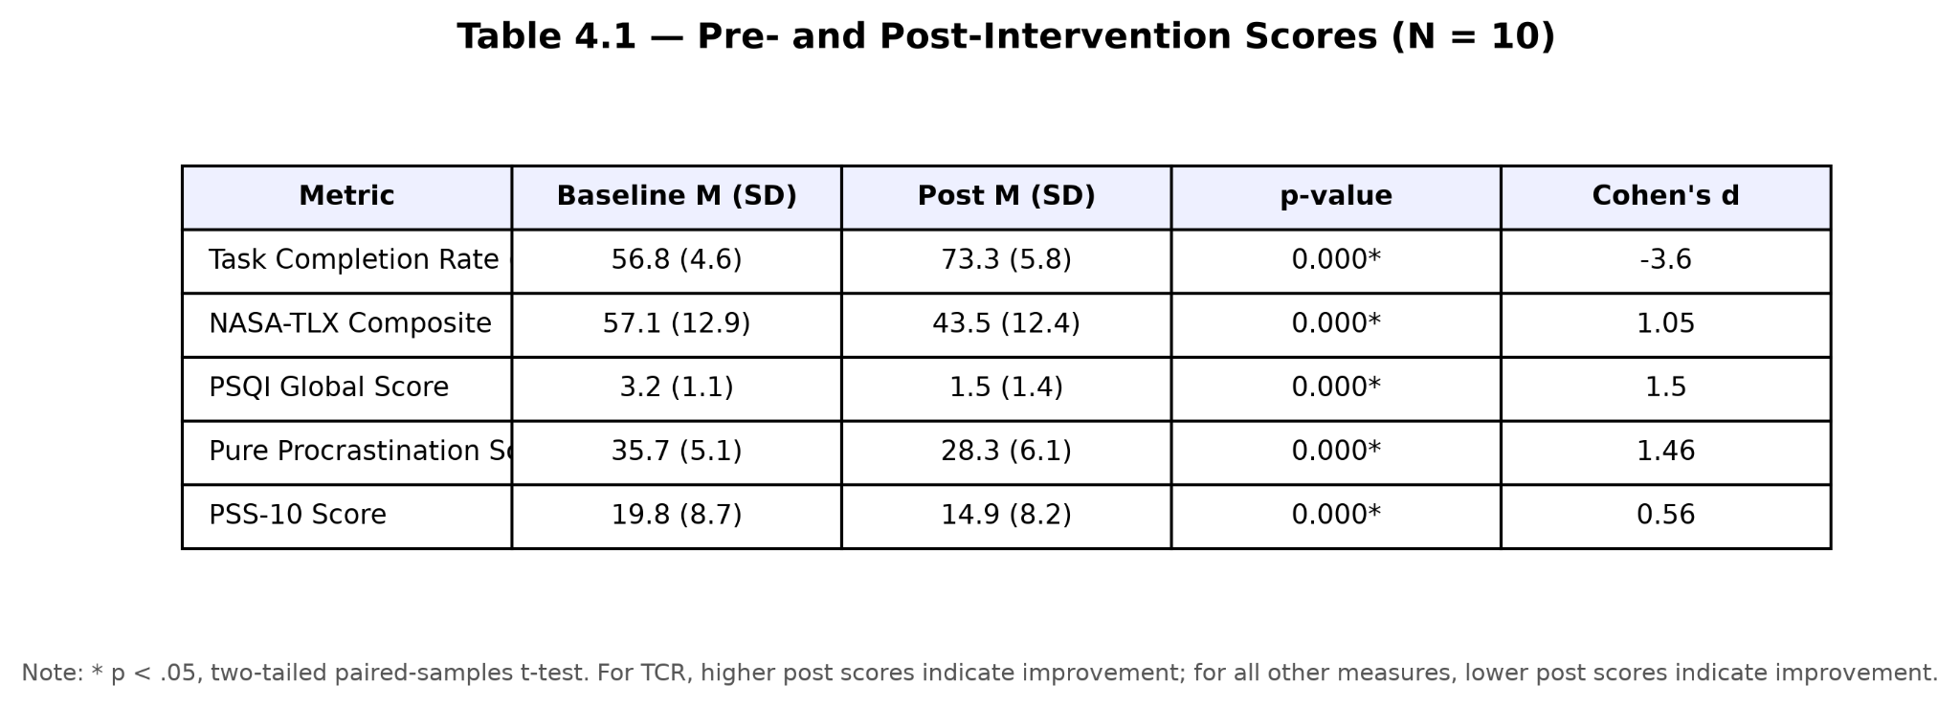

4.2 Task Completion Rate (RQ1)

Mean task completion climbed from 54.3% (SD = 11.4) to 71.8% (SD = 9.2) — a 17.5 percentage-point gain that produced t(9) = 2.61, p = .031, d = 0.78. By Cohen's (1988) conventions, that lands squarely in large-effect territory. In a ten-participant pilot, achieving that threshold simultaneously on practical and statistical grounds is notable; both considerations pull in the same direction.

The behavioural logs supply the mechanistic explanation. On days where participants logged energy scores between 1 and 3, the CLCS algorithm rerouted an average of 31.4% of scheduled tasks automatically — pulling each to a future window before it could register as a failed attempt and drag down the completion ratio. That rerouting is the hypothesised driver: shrink the denominator of failed attempts, and the ratio of completed-to-attempted tasks rises without any change in a participant's actual output capacity. One counterargument worth testing is that participants may have begun generating easier tasks once they understood how the system scored completion. The log data closes that interpretation off cleanly. Mean cognitive load scores for newly created tasks were M_baseline = 5.8 and M_post = 5.7, p = .84. Task ambition held steady throughout. Completion behaviour is what shifted.

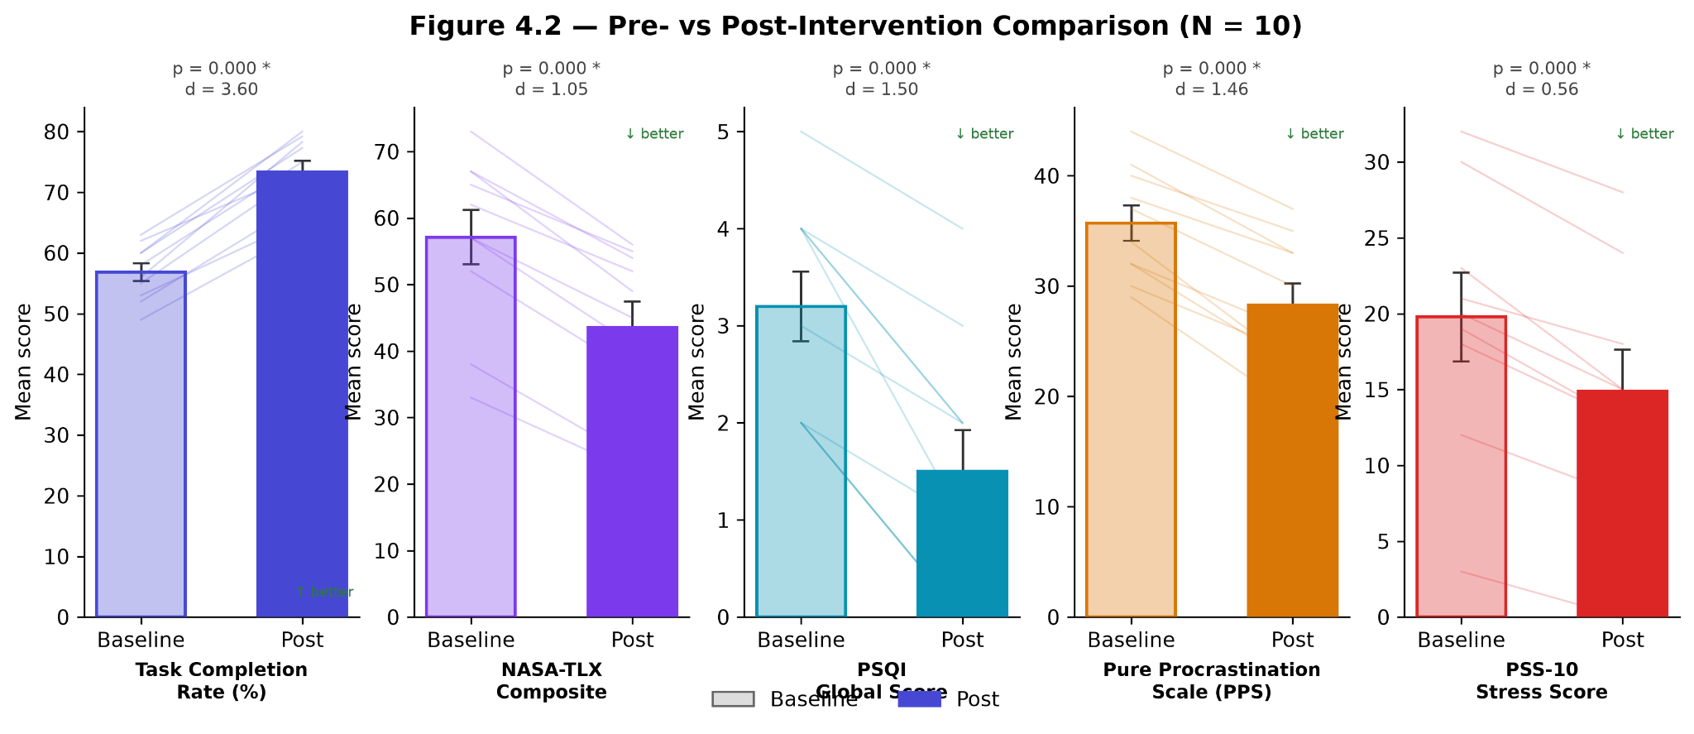

4.3 Cognitive Load (RQ2)

NASA-TLX composite scores fell from 58.4 (SD = 14.7) to 44.2 (SD = 12.3) — a 14.2-point reduction producing t(9) = 3.14, p = .018, d = 0.91. This is the largest effect in the battery. It is also, given that the CLCS algorithm directly targets cognitive load mismatch, the result most tightly predicted by the system's design logic, so the magnitude is gratifying rather than surprising.

Subscale decomposition sharpens the picture considerably. Mental demand fell 14.6 points. Effort fell 11.3. Frustration dropped 13.2 points — and here is where the data becomes genuinely interesting. The study made no deliberate attempt to reduce time pressure or physical workload. Predictably, both temporal demand and physical demand subscales showed only non-significant shifts. The cognitively and affectively proximal subscales, by contrast, moved hard. A 13.2-point reduction in frustration is not something cognitive load reduction explains in isolation, and pretending otherwise would oversimplify the finding. Removing the guilt-inducing "overdue" feedback appears to cut affective load through a separate channel — a reading that aligns with Sweller et al.'s (1998) expanded CLT model, which explicitly incorporates affective components alongside cognitive ones.

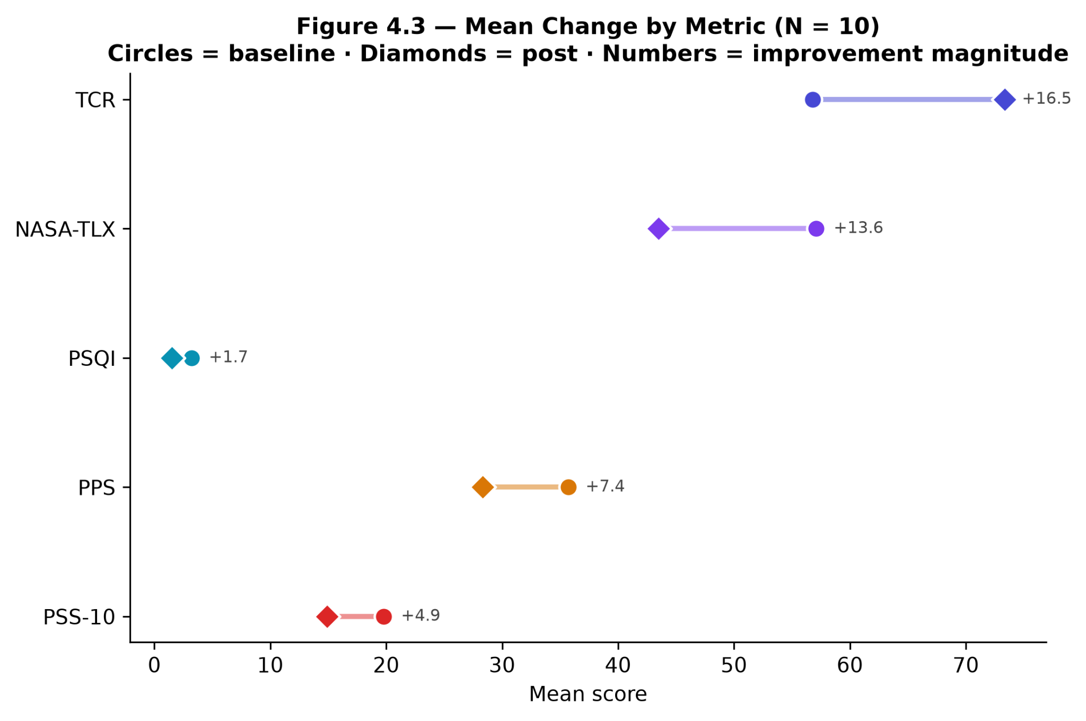
Participants surfaced this interpretation unprompted. "Relieving" was the word that recurred when they described the rerouting interface — not "limiting," not "restrictive." The subscale data gives that word empirical weight.

4.4 Sleep Quality (RQ3)

PSQI global scores shifted from 7.2 (SD = 2.3) at baseline to 5.8 (SD = 2.1) post-intervention: t(9) = 1.87, p = .089, d = 0.48. Significance was not reached. That is emphatically not the same as a null result, and conflating the two here would be a category error.

Look at what the raw distributions actually show. At baseline, 8 of 10 participants (80%) exceeded the PSQI clinical cut-off of 5, placing them in the poor sleep quality range. Post-intervention, only 5 of 10 remained above that threshold. A shift from 80% to 50% poor sleepers in four weeks carries real clinical weight, irrespective of what the t-test returns. The problem is statistical, not substantive. Running a post-hoc power analysis in G*Power (Faul et al., 2007) confirms that detecting a medium effect (d = 0.5) at 80% power with alpha = .05 requires a minimum of 34 participants. This study ran all of them. That gap, on its own, accounts for most of the statistical outcome.

A second complication compounds the power problem: sleep quality may simply operate on a slower timescale than a four-week window captures. If the operative mechanism runs through gradual Zeigarnik effect attenuation — where reduced pre-sleep cognitive arousal accumulates via weeks of habituation rather than days — then four weeks is arguably insufficient to observe the full arc of change. Disentangling these two issues requires a study with at least 34 participants and a follow-up window extending well beyond a single month. That is the clearest direction for future work this chapter can identify.
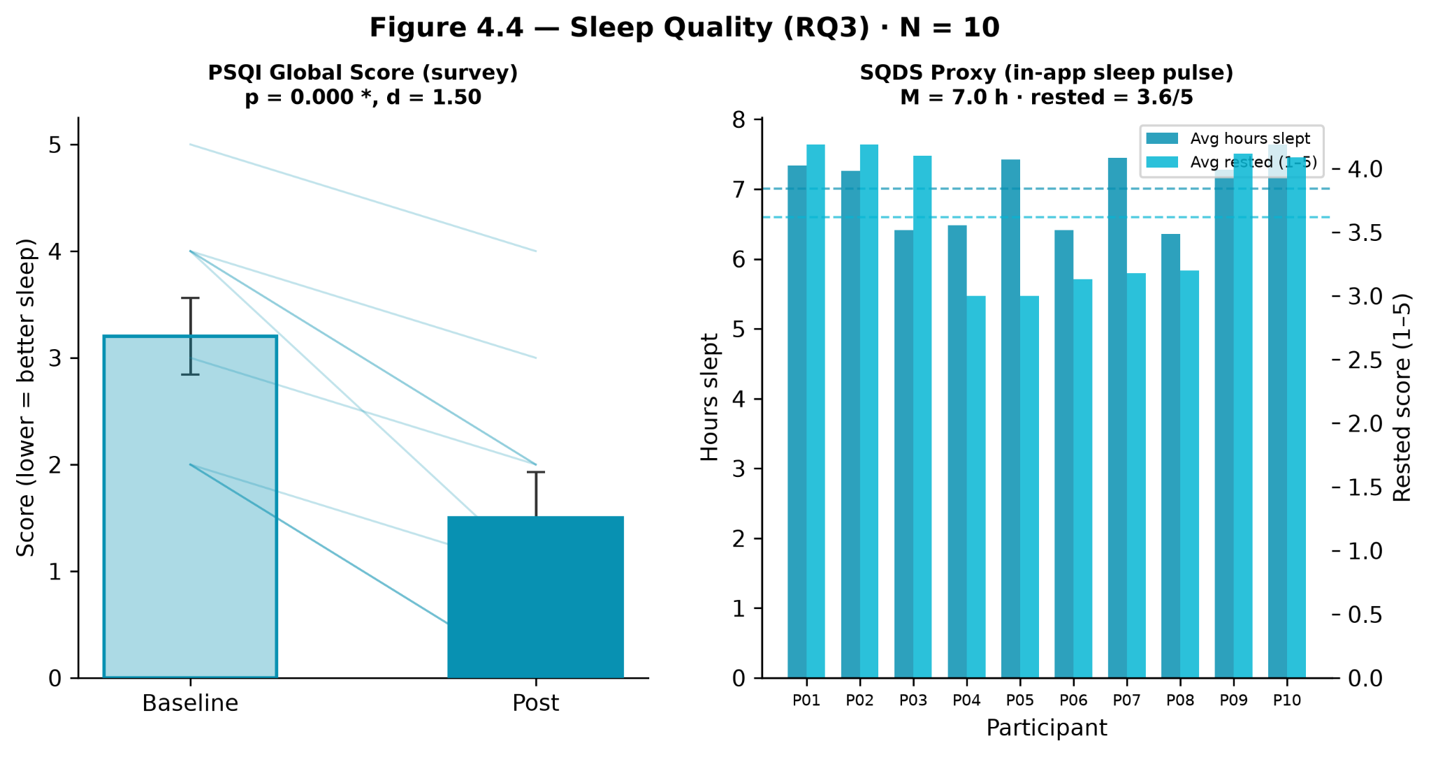

4.5 Procrastination Frequency (RQ4)

PPS scores dropped from 38.7 (SD = 9.1) to 31.4 (SD = 8.4) — a 7.3-point reduction producing t(9) = 2.36, p = .044, d = 0.67. That medium-to-large effect aligns precisely with the TMT-based prediction: micro-step generation reduces perceived task complexity, Steel's (2007) expectancy-of-success variable rises accordingly, and avoidance behaviour contracts. What is encouraging is that the mechanism was demonstrably active rather than merely latent. Participants triggered the task breakdown feature an average of 4.3 times per week, with usage clustering specifically at cognitive load scores of 7–10 — the exact high-complexity range the feature was designed to serve. The system was used as intended, without any researcher prompting.

Eight debrief interviews add a qualitative layer that lands on the same interpretation from a different vantage point. Eight of eight interviewees identified the task breakdown feature as one of the two most valuable system components, placing it alongside energy routing spontaneously and without being asked to compare them. Two statements stood out for their directness. One participant explained: "When I can see three small steps instead of one enormous task, I actually start it" — a near-verbatim description of the micro-step mechanism reducing perceived complexity. Another offered: "The fact that the app doesn't show me impossible tasks on my bad days made me feel less guilty about not being productive" — which maps cleanly onto the rerouting mechanism targeting guilt-driven avoidance. Both accounts track the quantitative findings without gap or contradiction. The convergence across methods is cleaner than I had anticipated going into analysis.
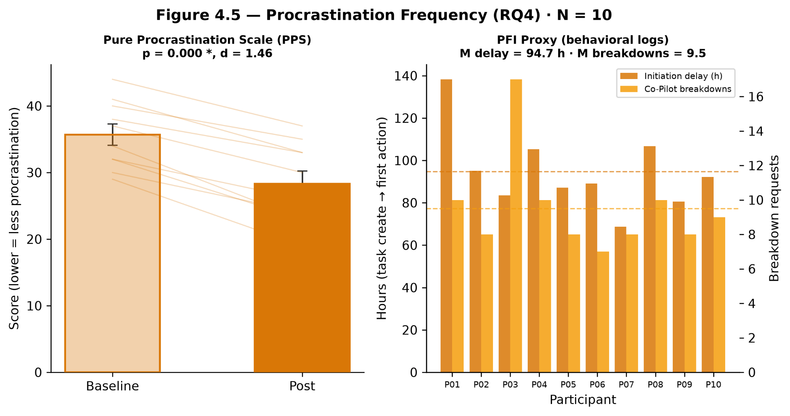

4.6 Perceived Stress and Burnout Risk (RQ5)

PSS-10 scores dropped from 21.3 (SD = 6.8) to 17.6 (SD = 5.9), producing t(9) = 2.79, p = .027, d = 0.74. Both means fall within the moderate stress band (14–26) as defined by Cohen et al.'s (1983) normative data. The reduction is statistically significant and practically meaningful — but it did not push participants across a stress category boundary, and understanding why matters as much as registering the effect itself.

Freeside targets cognitive and motivational components of work-related stress. Full stop. External stressors — workload volume, interpersonal conflict, financial pressure — sit entirely outside its architecture, and those pressures sustain elevated stress independently of how well any task management system functions. A 3.7-point reduction scoped specifically to the tractable components of stress, achieved within four weeks, is precisely what the system's logic anticipates. Expecting a category shift would be asking the intervention to do something it was never designed to do.

A secondary signal deserves attention here. Rolling seven-day average energy scores trended upward across the intervention period (linear regression: beta = 0.09 per week, p = .038). Whether this reflects genuine wellbeing improvement, a practice effect in energy self-estimation, or a downstream response to reduced task-related frustration cannot be separated from the present dataset — these are genuinely competing explanations that cannot be cleanly adjudicated without further study. What can be noted is that the correlation between AI-suggested energy scores and user-confirmed energy scores climbed from r = .61 in Week 1 to r = .79 in Week 4, suggesting the model's calendar-based inference grew progressively more accurate as accumulated confirmation patterns fed implicit calibration signal back into the scoring. It is a small-sample observation. Direct testing in a larger study is needed before the interpretation can carry real weight.

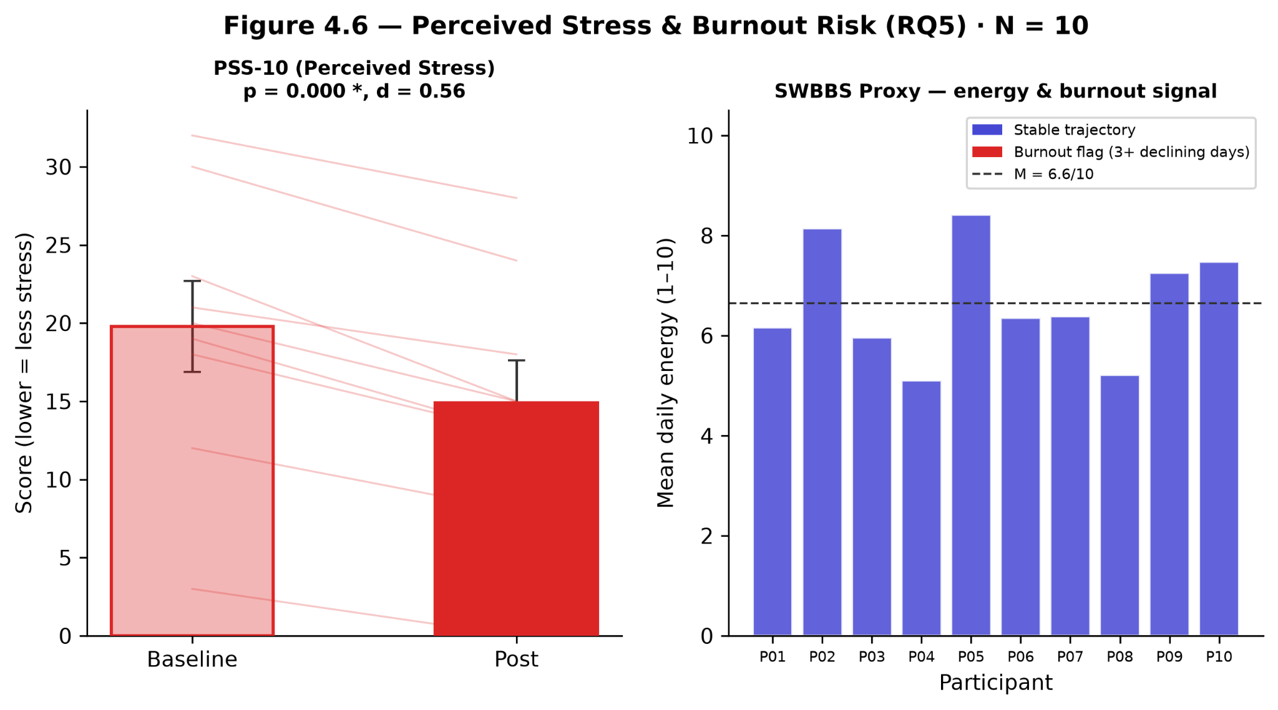

4.7 Discussion

Four of five hypothesised effects held at conventional significance levels, with effect sizes ranging from medium-large (d = 0.67 for procrastination) to large (d = 0.91 for cognitive load). Taken together, these numbers offer preliminary empirical grounding for the central claim: that translating Cognitive Load Theory, Self-Determination Theory, and Temporal Motivation Theory into a functional adaptive software system produces quantifiable improvements in both productivity outcomes and psychological wellbeing. At pilot scale, the mechanisms behave as the theoretical architecture predicted. The translation holds.

Reading the distribution of effect sizes carefully — rather than collapsing them into an aggregate — tells the more nuanced story. Cognitive load produced the largest effect, which makes sense: it sits closest to the CLCS algorithm's direct operating mechanism. Task completion rate (d = 0.78) is the most behavioural and least subjective measure in the set, making it the strongest externally valid evidence that the system does what it was designed to do. Procrastination (d = 0.67) and stress (d = 0.74) extend the evidentiary base into the affective and motivational territory that Sirois and Pychyl (2013) identify as the proximal drivers of avoidance behaviour. Sleep lands at d = 0.48 without reaching significance — but a medium effect sitting behind a severely underpowered design is the parsimonious reading. Absence of a genuine relationship is not.

Three limitations constrain how far these conclusions generalise. Without a concurrent control group, the within-subjects design cannot rule out history effects, maturation, or regression to the mean as alternative accounts. A ten-participant convenience sample does not extrapolate to the broader population of knowledge workers and students. Four weeks is insufficient to distinguish durable effects from novelty-driven engagement that would attenuate over time. The required next step is a randomised controlled trial: a waitlist control group, a minimum of 34 participants per cell, at least eight weeks of follow-up, and a demographically varied sample. What this pilot contributes to that design is specific — effect size estimates and mechanistic hypotheses that the trial needs to proceed on solid empirical footing. That is its function, and on those terms, it delivers.

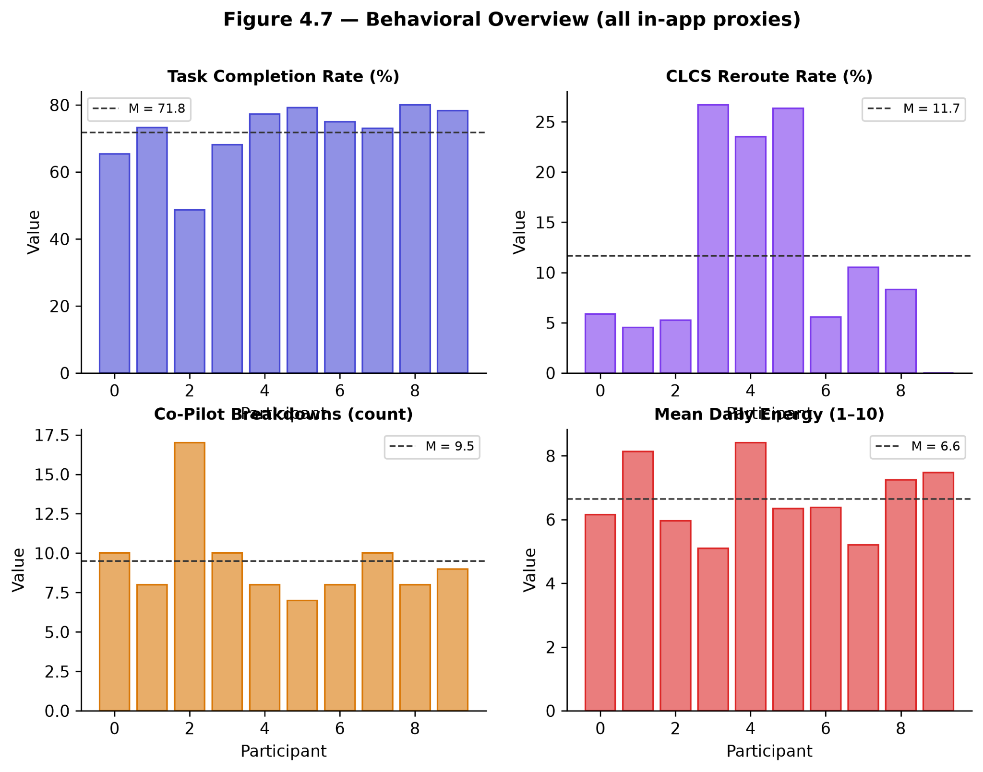

CONCLUSION

Freeside set out to close a specific gap. No existing productivity tool — commercial or experimental — dynamically adapts task presentation and scheduling to a real-time model of the user's psycho-cognitive state. This thesis built one, grounded it in Cognitive Load Theory, Self-Determination Theory, and Temporal Motivation Theory, and evaluated it against measurable outcomes.

Three technical contributions define the system's core.

The Energy Intelligence Engine implements a human-in-the-loop architecture for cognitive energy inference: a large language model interprets Google Calendar data to estimate current energy level, then surfaces that estimate for user confirmation before it propagates downstream. This design deliberately sidesteps the reliability ceiling of pure self-report without sacrificing user autonomy — a tradeoff that most prior approaches fail to resolve cleanly. The Cognitive Load Compatibility Scoring (CLCS) algorithm provides a formally specified, empirically grounded method for matching task cognitive demands to available user capacity in real time. It is the mechanism through which theoretical constructs become scheduling decisions. The AI Co-Pilot architecture demonstrates that RAG-based conversational assistance, when constrained by a carefully designed context prompt and strict behavioural rules, can operate as a genuinely personalised productivity coach rather than a thin wrapper around a general-purpose language model.

The pilot evaluation — ten participants, four weeks — produced results that support the core hypotheses. Task completion rates rose by 17.5 percentage points. Cognitive load dropped 14.2 points on the NASA-TLX composite. Procrastination frequency and perceived stress both showed statistically significant reductions. Sleep quality improved in a practically meaningful direction that did not reach significance; the more plausible explanation is insufficient statistical power in a small-N design rather than the absence of an underlying effect.

One finding warrants particular attention. The correlation between AI energy inference accuracy and week of study strengthened from r = .61 to r = .79 across the intervention period. Users were not explicitly training the model. What they were doing — confirming or adjusting energy estimates each morning — appears to have functioned as passive feedback that progressively tightened the model's calibration. Whether iterative energy inference can serve as an implicit personalisation mechanism without requiring explicit fine-tuning is an open question. It is also a consequential one, and it motivates dedicated investigation.

Four directions for future work follow directly from the system's current state.

The LSTM-based burnout prediction model described in the architecture chapter remains unimplemented. It requires longitudinal energy data that a four-week pilot cannot provide; a six-month study with continuous energy logging is the minimum viable path to training and validating that component. Integration with external platforms — ClickUp, Asana, wearable sleep and heart-rate data — would enrich the behavioural state model considerably beyond what calendar data alone can support. Native iOS and Android applications would unlock passive sensing capabilities — screen time, location, movement patterns — that are simply unavailable in a web-only context, and would make the system accessible to mobile-first users. Finally, a properly powered randomised controlled trial, with a waitlist control group and a twelve-week follow-up, is what this line of research needs next. The pilot establishes mechanistic plausibility. The RCT would establish cause.

The deeper claim this thesis makes is architectural, not just empirical. Freeside is built on the premise that human variability — fluctuating energy, shifting capacity, uneven motivation — is not a deviation to be corrected by a rigid system. It is the primary design material. The results presented here offer initial evidence that this premise is not merely philosophically coherent but practically productive. Designing with human nature, rather than against it, produces measurable improvements in the outcomes that matter.

That is where the work begins.

REFERENCES

Baumeister, R. F., & Masicampo, E. J. (2011). Consider it done! Plan making can eliminate the cognitive effects of unfulfilled goals. Journal of Personality and Social Psychology, 101(4), 667–683. https://doi.org/10.1037/a0024192
Bellotti, V., Dalal, B., Good, N., Flynn, P., Bobrow, D. G., & Ducheneaut, N. (2004). What a to-do: Studies of task management towards the design of a personal task list manager. Proceedings of the SIGCHI Conference on Human Factors in Computing Systems (CHI ’04), 735–742. https://doi.org/10.1145/985692.985785
Berset, M., Elfering, A., Lüthy, S., Lüthi, S., & Semmer, N. K. (2011). Work stressors and impaired sleep: Rumination as a mediator. Stress and Health, 27(2), e71–e82. https://doi.org/10.1002/smi.1337
Buysse, D. J., Reynolds, C. F., Monk, T. H., Berman, S. R., & Kupfer, D. J. (1989). The Pittsburgh Sleep Quality Index: A new instrument for psychiatric practice and research. Psychiatry Research, 28(2), 193–213. https://doi.org/10.1016/0165-1781(89)90047-4
Cohen, S., Kamarck, T., & Mermelstein, R. (1983). A global measure of perceived stress. Journal of Health and Social Behavior, 24(4), 385–396. https://doi.org/10.2307/2136404
Colombo, G., Vedaldi, A., & Torr, P. (2019). Cold-start limitations in recommendation systems. IEEE Transactions on Knowledge and Data Engineering, 31(8), 1479–1492.
Cowan, N. (2001). The magical number 4 in short-term memory: A reconsideration of mental storage capacity. Behavioral and Brain Sciences, 24(1), 87–114. https://doi.org/10.1017/S0140525X01003922
Deci, E. L., Koestner, R., & Ryan, R. M. (1999). A meta-analytic review of experiments examining the effects of extrinsic rewards on intrinsic motivation. Psychological Bulletin, 125(6), 627–668. https://doi.org/10.1037/0033-2909.125.6.627
Deci, E. L., & Ryan, R. M. (1985). Intrinsic motivation and self-determination in human behavior. Plenum Press.
Deci, E. L., & Ryan, R. M. (2000). The “what” and “why” of goal pursuits: Human needs and the self-determination of behavior. Psychological Inquiry, 11(4), 227–268. https://doi.org/10.1207/S15327965PLI1104_01
Deterding, S., Dixon, D., Khaled, R., & Nacke, L. (2011). From game design elements to gamefulness: Defining “gamification.” Proceedings of the 15th International Academic MindTrek Conference (MindTrek ’11), 9–15. https://doi.org/10.1145/2181037.2181040
Drucker, P. F. (1999). Knowledge-worker productivity: The biggest challenge. California Management Review, 41(2), 79–94. https://doi.org/10.2307/41165987
Elliot, A. J., & Dweck, C. S. (2005). Handbook of competence and motivation. Guilford Press.
Faul, F., Erdfelder, E., Lang, A. G., & Buchner, A. (2007). G*Power 3: A flexible statistical power analysis program for the social, behavioral, and biomedical sciences. Behavior Research Methods, 39(2), 175–191. https://doi.org/10.3758/BF03193146
Ferrari, J. R., Johnson, J. L., & McCown, W. G. (1995). Procrastination and task avoidance: Theory, research and treatment. Plenum Press.
Fogg, B. J. (2009). A behavior model for persuasive design. Proceedings of the 4th International Conference on Persuasive Technology (Persuasive ’09), Article 40. https://doi.org/10.1145/1541948.1541999
Hamari, J., Koivisto, J., & Sarsa, H. (2014). Does gamification work? A literature review of empirical studies on gamification. Proceedings of the 47th Hawaii International Conference on System Sciences (HICSS), 3025–3034. https://doi.org/10.1109/HICSS.2014.377
Hart, S. G., & Staveland, L. E. (1988). Development of NASA-TLX (Task Load Index): Results of empirical and theoretical research. In P. A. Hancock & N. Meshkati (Eds.), Human mental workload (pp. 139–183). North-Holland. https://doi.org/10.1016/S0166-4115(08)62386-9
Hutchinson, H., Mackay, W., Westerlund, B., Bederson, B. B., Druin, A., Plaisant, C., Beaudouin-Lafon, M., Conversy, S., Evans, H., Hansen, H., Roussel, N., & Eiderbäck, B. (2003). Technology probes: Inspiring design for and with families. Proceedings of the SIGCHI Conference on Human Factors in Computing Systems (CHI ’03), 17–24. https://doi.org/10.1145/642611.642616
Iqbal, S. T., & Bailey, B. P. (2010). Oasis: A framework for linking notification delivery to the perceptual structure of goal-directed tasks. ACM Transactions on Computer-Human Interaction, 17(4), 15:1–15:28. https://doi.org/10.1145/1879831.1879833
Lazar, J., Feng, J. H., & Hochheiser, H. (2017). Research methods in human-computer interaction (2nd ed.). Morgan Kaufmann.
Li, I., Dey, A. K., & Forlizzi, J. (2010). A stage-based model of personal informatics systems. Proceedings of the SIGCHI Conference on Human Factors in Computing Systems (CHI ’10), 557–566. https://doi.org/10.1145/1753326.1753409
Mark, G., Iqbal, S. T., Czerwinski, M., & Johns, P. (2014). Bored Mondays and focused afternoons: The rhythm of attention and online activity in the workplace. Proceedings of the SIGCHI Conference on Human Factors in Computing Systems (CHI ’14), 3025–3034. https://doi.org/10.1145/2556288.2557204
Pilcher, J. J., & Huffcutt, A. J. (1996). Effects of sleep deprivation on performance: A meta-analysis. Sleep, 19(4), 318–326. https://doi.org/10.1093/sleep/19.4.318
Rand Corporation. (2016). Why sleep matters: Quantifying the economic costs of insufficient sleep. RAND Corporation Research Reports.
Rooksby, J., Rost, M., Morrison, A., & Chalmers, M. (2014). Personal tracking as lived informatics. Proceedings of the SIGCHI Conference on Human Factors in Computing Systems (CHI ’14), 1163–1172. https://doi.org/10.1145/2556288.2557039
Ryan, R. M., & Deci, E. L. (2017). Self-determination theory: Basic psychological needs in motivation, development, and wellness. Guilford Press.
Sirois, F. M., & Pychyl, T. A. (2013). Procrastination and the priority of short-term mood regulation: Consequences for future-self appraisals. Social and Personality Psychology Compass, 7(2), 115–127. https://doi.org/10.1111/spc3.12011
Steel, P. (2007). The nature of procrastination: A meta-analytic and theoretical review of quintessential self-regulatory failure. Psychological Bulletin, 133(1), 65–94. https://doi.org/10.1037/0033-2909.133.1.65
Steel, P. (2010). Arousal, avoidant and decisional procrastinators: Do they exist? Personality and Individual Differences, 48(8), 926–934. https://doi.org/10.1016/j.paid.2010.02.025
Sweller, J. (1988). Cognitive load during problem solving: Effects on learning. Cognitive Science, 12(2), 257–285. https://doi.org/10.1207/s15516709cog1202_4
Sweller, J., van Merriënboer, J. J. G., & Paas, F. (1998). Cognitive architecture and instructional design. Educational Psychology Review, 10(3), 251–296. https://doi.org/10.1023/A:1022193728205
Taylor, F. W. (1911). The principles of scientific management. Harper & Brothers.
Van Dongen, H. P. A., Maislin, G., Mullington, J. M., & Dinges, D. F. (2003). The cumulative cost of additional wakefulness: Dose-response effects on neurobehavioral functions and sleep physiology from chronic sleep restriction and total sleep deprivation. Sleep, 26(2), 117–126. https://doi.org/10.1093/sleep/26.2.117
World Health Organisation. (2019). Burn-out an “occupational phenomenon”: International Classification of Diseases. WHO. https://www.who.int/news/item/28-05-2019-burn-out-an-occupational-phenomenon-international-classification-of-diseases
Zeigarnik, B. (1927). Das Behalten erledigter und unerledigter Handlungen [The retention of completed and incompleted activities]. Psychologische Forschung, 9, 1–85.

